YOUNG VOLUNTEERS LEAD THE WAY IN REMEMBRANCE AND ENCOURAGE FUTURE GENERATIONS TO NEVER FORGET

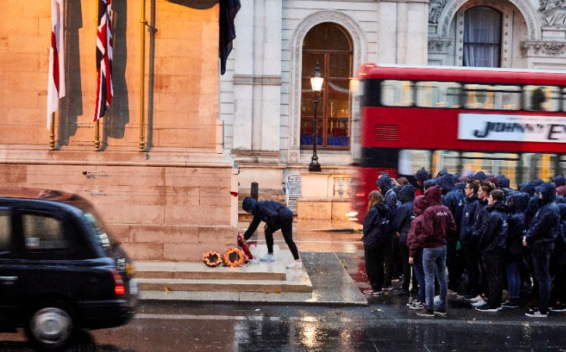

100 National Citizen Service (NCS) graduates volunteered at this year's Remembrance events in London. The young people represented their generation at the highly significant national event marking 100 years since the Armistice of the First World War. They were chosen due to their passion for ensuring the tradition of Remembrance continues and the great sacrifice men and women have made for our country is not forgotten.
NCS grads were at the forefront of the event in roles that will require them to engage with the members of the public throughout their experience. They lead the way, representing young people of England and Northern Ireland, as well as advocating for NCS on a national stage. Their roles included working alongside Department for Digital, Culture, Media & Sport (DCMS) officials through the accreditation and arrival process; wayfinding and supporting guest as they prepare for the procession; leading the procession columns of up to 800 people along the procession route; and managing the wreath laying at the Cenotaph.

Harrison Burns, an 18-year-old descendent of a World War One (WW1) veteran from Colchester, and one of 100 National Citizen Service graduates who took part, said:
“Young people have a duty to carry forward the stories and memories of fallen soldiers, so that we do not forget the sacrifice they made for our country.
“NCS allowed me to help spread the importance of Remembrance Day amongst young people so that I could tell the story of my family’s heroes who served in World War One, making sure that they are not forgotten.
“Young people need to understand that without the sacrifice of these men, we wouldn’t have the country that we all live in today.

About NCS
NCS is a government backed programme established in 2011 to help build a more cohesive, mobile and engaged society. By bringing together young people from different backgrounds for a unique shared experience, NCS helps them to become better individuals, and in turn better citizens.

NCS is open to 16 and 17 year-olds across England and Northern Ireland. The two to four week programme, which takes place in school holidays, includes outdoor team-building exercises, a residential for participants to learn ‘life skills’, a community-based social action project and an end of programme celebration event.

To date:
- Almost 500,000 young people have taken part
- Twelve million hours of community action have been completed
- For every £1 spent, NCS’ 2016 summer programme delivered between £1.15 and £2.42 of benefits back to society
It costs participants just £50 or less to take part in NCS and bursaries are available on a case by case basis. Support is provided for young people with additional needs.

To find out more visit NCSyes.co.uk.

About NCS Trust
National Citizen Service Trust is a not-for-profit organisation incorporated by Royal Charter and established to shape, support, champion and lead a thriving National Citizen Service.

National Citizen Service Trust is registered in England and Wales with Royal Charter Body number RC000894. Our registered office is at The Pembroke Building, Kensington Village, Avonmore Road, London, W14 8DG.

